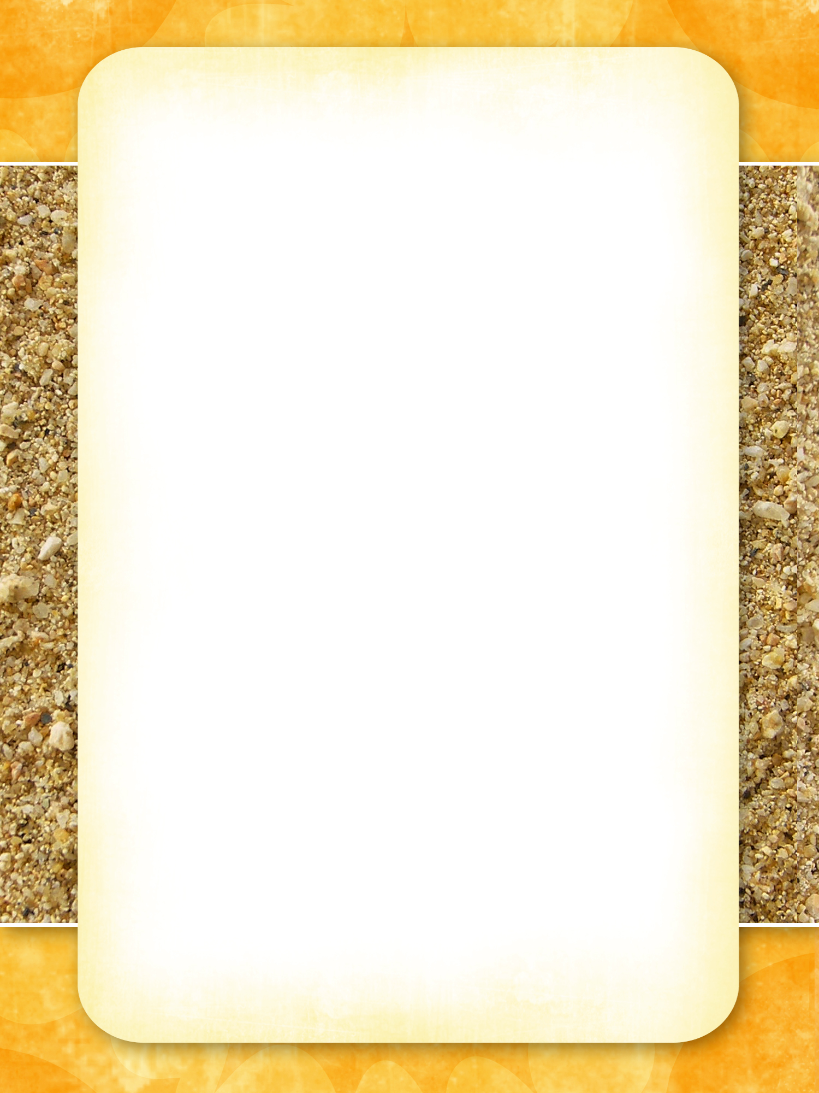

# Bar Menu

**Happy Hour Every Day 6-7pm - All Drinks 50% Off the Marked Price**

## Beers

On tap **Schooner Middy**

* Victoria Bitter, Hann Super Dry or XXXX Gold $5.00 $4.00

Bottles (375mm) Bottle (375ml)

* Boags Premium, Crown Larger or Cascade Larger $6.00

## Wine Bottle Glass

* Mad Dog Savion Blanc 1999 (Hunter Valley) $25.00 $7.00
* Fifth Leg Chardonnay 2014 (Tasmania) $27.00 $8.50
* Cloudy Bay Riesling 2013 (Marlborough NZ) $30.00 $9.00

## Spirits Nip With Mixer

* Bundaberg Rum, Smirnoff Vodka or Johnny Walker Red $5.00 $6.75
* Johnny Walker Black, Canadian Club, St Fred’s Cognac $9.00 $11.75

## Cocktails

* Slammers Delight (The Specialty - Drink Rum, Vodka & Fruit) $11.00
* B52 (Irish Cream, Kahlúa & Grand Marnier) $11.50
* Blue Moon (Blue Curaçao, Vodka, Cointreau, OJ& Vanilla Syrup) $11.50
* Mock Tail - Sangria (black tea, cinnamon pomegranate, apple & OJ) $11.50
* Mock Tail – Pina Colada (Pineapple, Coconut, Apple & Vanilla) $11.50
* Bloody Mary (Vodka, Tomato Juice, Lime & Worcestershire Sauce,) $12.00

## Water, Soft Drinks or Juice Glass

* Still or Sparkling Water $1.50
* Coke, Pepsi, Lemonade & Lemon Squash $.2.00
* Orange, Cranberry or Pineapple Juice $2.50